1. **Brief Introduction**

My feature for the game *Septicemia* will be the creation of partially destructible

environments that house the play area and the collectibles within it.

When the level is created, my job is to generate the environment by combining

pre-made areas in a semi-random way, always including an open main area and

the player shop. I am also tasked with making sure that when the player attacks

a destructible wall, it triggers the wall to be destroyed and reveals the hidden

room behind it.

1. **Use case diagram with scenario**

**Use case diagrams**:

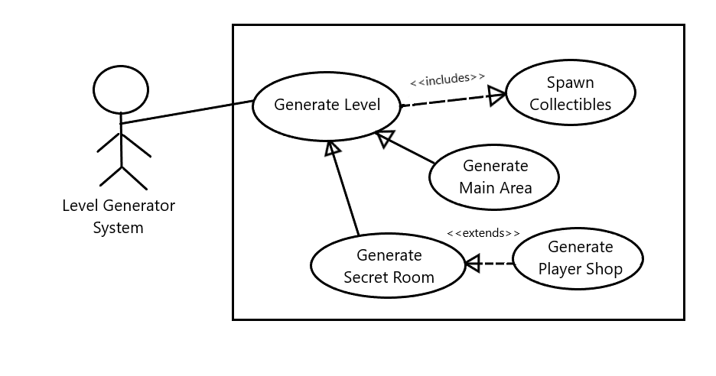

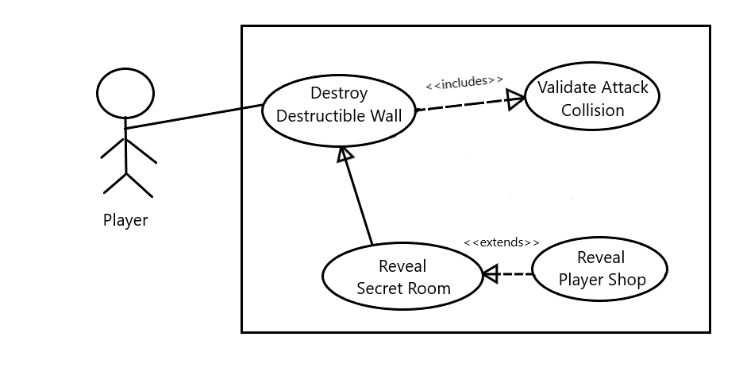

**Scenarios**:

Scenario 1 (1st Diagram)

Name: Generate Level

Summary: The level generator system generates the play space by

surrounding the main area with randomly selected secret rooms.

Actors: Level Generator System

Preconditions: Player has selected Play Game from the menu.

Basic Sequence:

Step 1: The generator creates the main area.

Step 2: If the Player Shop has already been created, the generator

selects a secret room from a pool of pre-made designs and creates

it in one of the designated locations around the main area, and

masks it from the player’s view.

Step 3: Collectibles are spawned into the secret rooms to be

uncovered later.

Exceptions

Step 2: If the Player Shop has not been created, the generator will

create the Player Shop in one of the designated locations.

Post conditions: Level is generated

Priority: Must have

ID: LG1

Scenario 2 (2nd Diagram)

Name: Destroy Destructible Wall

Summary: When a player attacks a destructible wall, it will trigger an event that reveals the secret room behind it.

Actors: Player

Preconditions: Player is attacking,

Basic Sequence:

Step 1: If a player’s attack hits a destructible wall, trigger an event.

Step 2: Event will cause the wall to disappear and the attached

secret room to be revealed.

Exceptions:

Step 2: If the room attached to the wall is the Player Shop, trigger

an event that reveals the room and plays a short cutscene.

Post conditions: An event is triggered.

Priority: Essential

ID: DW1

1. **Data Flow diagram(s) from Level 0 to process description for your feature**

**Data Flow Diagrams**

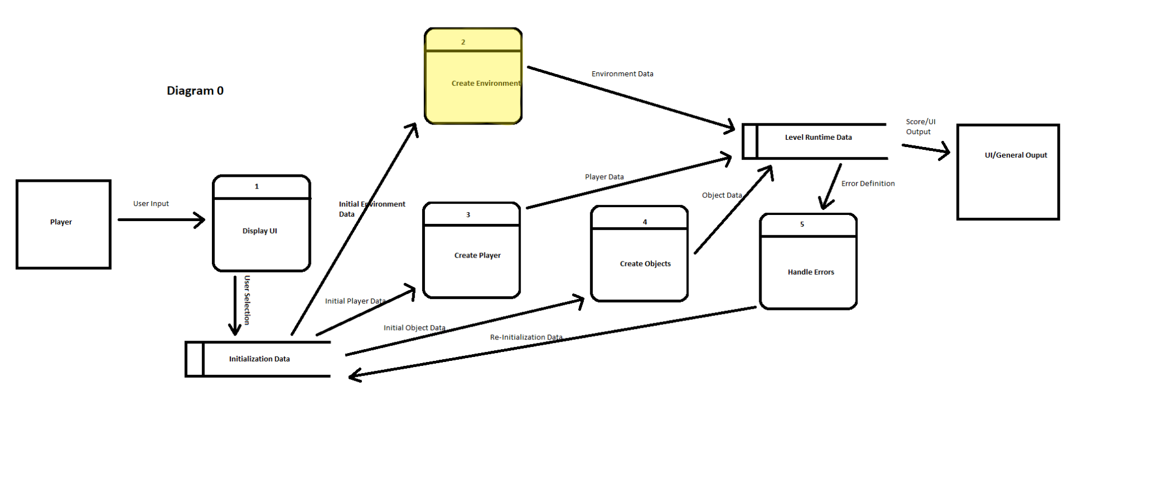

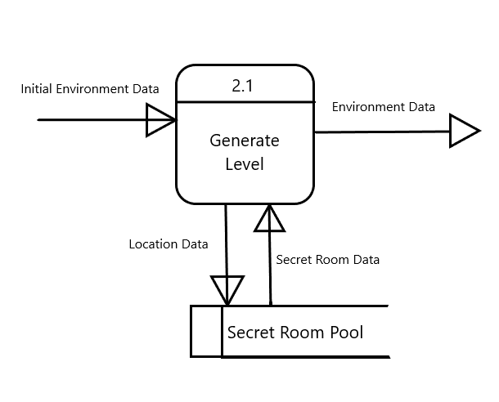

**Process Description**

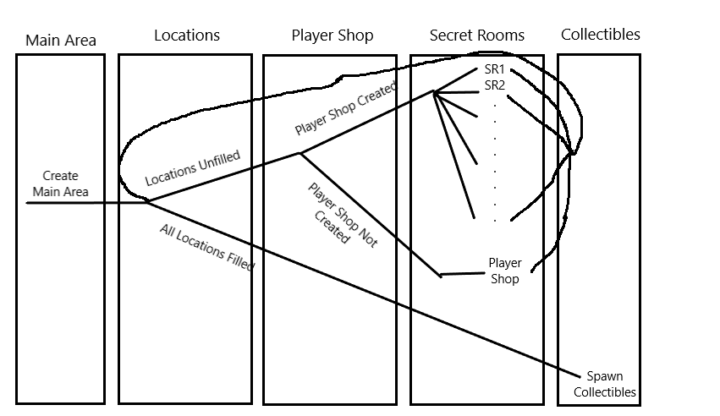

1. **Acceptance Tests**

As this feature contains some level of randomness, tests will have to be run many times to ensure every possibility is accounted for. The Level Generator will be set up to create 10 sample environments one after the other, and each will be checked for the location of the Player Shop, any overlaps between the rooms, and the player’s ability to destroy the walls. It will also be checked for incorrect references outside of the Secret Room Pool, repeating the same room, and any other problems that may arise.

1. **Timeline**

| **Tasks** | **Duration (hrs)** | **Predecessor Task(s)** |
| --- | --- | --- |
| 1. Research and Development | 5 | - |
| 1. Room Data Structure Creation | 4 | 1 |
| 1. Generation Procedure Programming | 12 | 2, 4 |
| 1. Collectible Spawn Programming | 5 | 1 |
| 1. Main Area Design | 2 | 3 |
| 1. Secret Room Design | 10 | 5 |
| 1. Player Store Design | 4 | 5 |
| 1. Wall Destruction Programming | 8 | 6, 7 |
| 1. Store Cutscene Creation | 4 | 7 |
| 1. Documentation | 3 | 8 |
| 1. Testing | 5 | 8 |
| 1. Integration | 3 | 11 |
| 1. Artwork | 2 | - |

